# ED GIS Scripting Q3 Deployment

## Software Prerequisite

1. Use only SqlDevleoper.exe version that support spooling e.g.:

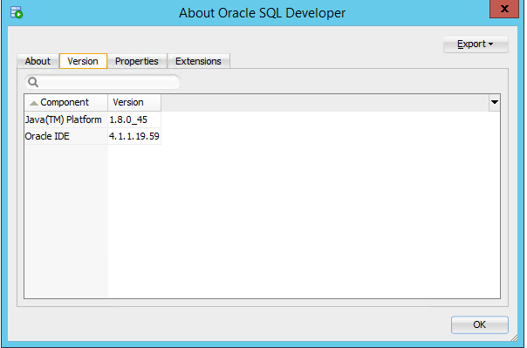

1. Verify your user has access to write to c:\temp directory

## Pre-DataModel Changes/Queries

### ArcFM Property Backup

1. Create Backup of ArcFM properties & Model Names files on the database:
   1. Connect to the database as EDGIS through ArcCatalog
   2. Right Click on connection and Click on ARCFM XML Export as per below screenshot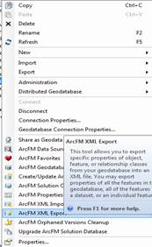
   3. **Check ArcFM Model Name Information & ARCFM Properties only** and browse a path to export XML as per below screenshot

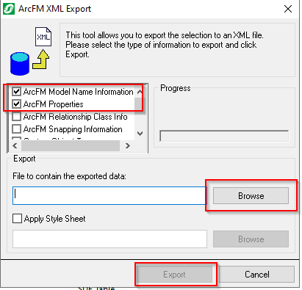

* 1. Click on Export. (It will take ~ 15 min to export)
  2. (Note – In case of any Warning/Error Notification, Inform to development team)
  3. Click on No as per below screen shot. 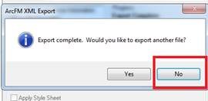
  4. Verify the export should be available at defined path

### HighSideConfiguration

1. Run SQL Queries for counts
   1. Open SQL Developer and Log into the Database with an appropriate account to make bulk updates
   2. Check the counts before running the update:
      1. Open \\sfshare04-nas2\sfgispoc_data\ApplicationDevelopment\EDScripting-Q3 Enhancements\Deployment\HighSide\CheckCountsBeforeBulkUpdate.sql
      2. Select Ctrl + A to select the whole file, then Click the Run Script button or hit F5 to run the script and select the appropriate connection. This will be written to a file in the c:\temp directory called HighSide_counts_before_update.txt
      3. Send output to project team

### Device Group

1. Run SQL Backup on Base and A Tables
2. Open SQL Developer and Log into the Database with an appropriate account to make bulk updates
3. Create a backout file before running the update:
4. Open the \\sfshare04-nas2\sfgispoc_data\ApplicationDevelopment\EDScripting-Q3 Enhancements\Deployment\DeviceGroup\DeviceGroup_Backup.sql   file
5. Select Ctrl + A to select the whole file, then Click the Run Script button or hit F5 to run the script.  This will be written to a file in the c:\temp directory called DeviceGroup_Restore.txt
6. Send the output to project team
7. Update Values for the domains that are being removed from the data model:
8. Open \\sfshare04-nas2\sfgispoc_data\ApplicationDevelopment\EDScripting-Q3 Enhancements\Deployment\DeviceGroup\DeviceGroupMove.sql  file.
9. Select Ctrl + A to select the whole file, then Click the Run Script button or hit F5 to run the script. Output will be displayed on screen. Save the output and send to the project team.

## DataModel Changes

### HighSideConfiguration/LowSideConfiguration

1. In ArcCatalog: Create a sde connection to the database being modified with the EDGIS user credentials and copy the path of the sde connection from the address bar to be used in the python scripts below.

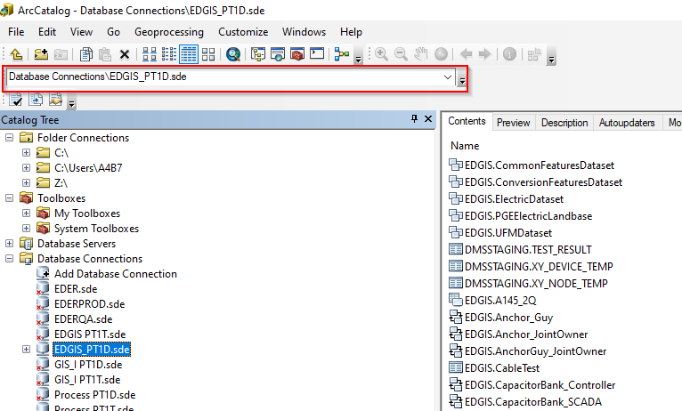

1. Verify that you have an exclusive lock on the database being upgraded and close ArcCatalog.
2. Run Python Script to update data model:
   1. Navigate to the \\sfshare04-nas2\sfgispoc_data\ApplicationDevelopment\EDScripting-Q3 Enhancements\Deployment\HighSide location
   2. Right-Click on the HighLowSideDataModelQ3-Part1.py file and Select Edit with IDLE

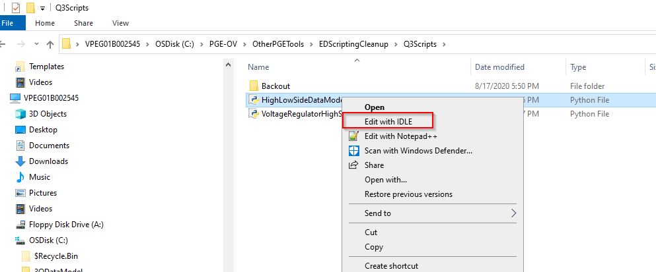

* 1. Modify the Data_Connection Parameter at the top of the script to match the data connection you create in step 1 and save the file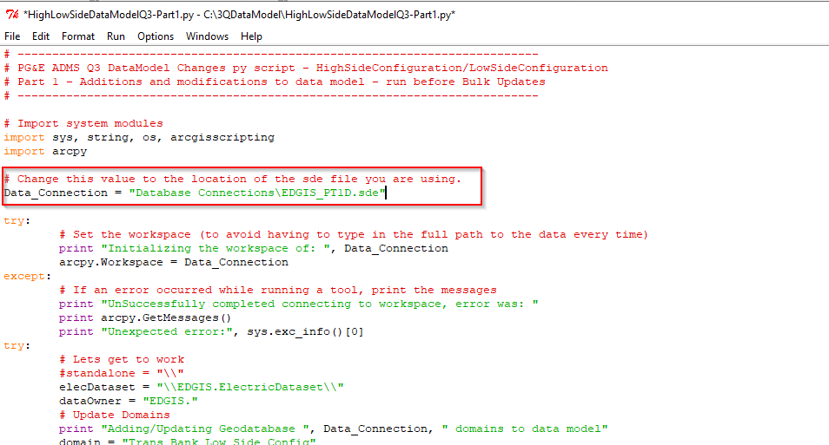
  2. Making sure you have an Exclusive Lock on the database, Select the Run menu from the menu bar and select Run Module

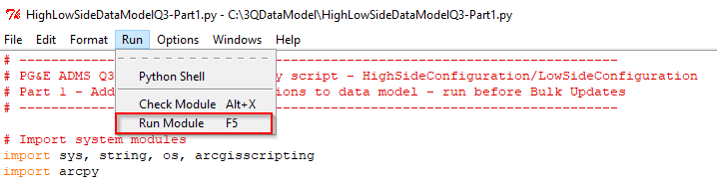

* 1. Wait for the script to complete, it will take about 5 minutes. The output window will list the steps as it processes and will list any errors that occur. If an error occurs (e.g. exclusive lock) you may need to comment out the lines that have already run and rerun after the error is resolved. A successful run will have output that looks like this: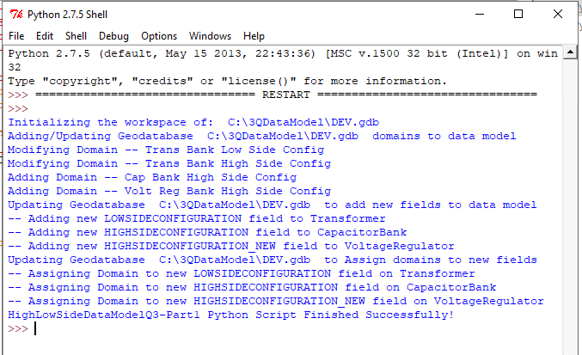

### FLISR

1. In ArcCatalog: Create a sde connection to the database being modified with the EDGIS user credentials and copy the path of the sde connection from the address bar to be used in the python scripts below.

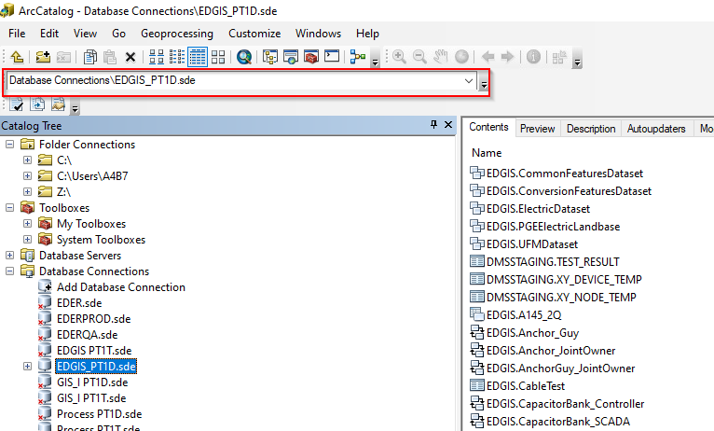

1. Verify that you have an exclusive lock on the database being upgraded and close ArcCatalog.
2. Run Python Script to update data model:
3. Navigate to \\sfshare04-nas2\sfgispoc_data\ApplicationDevelopment\EDScripting-Q3 Enhancements\Deployment\FLISR
4. Right-Click on the FLISR.py file and Select Edit with IDLE 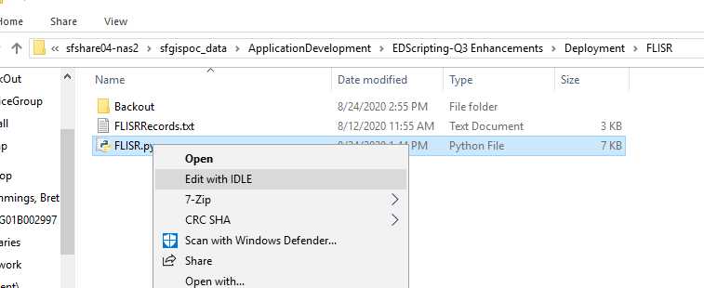
5. Modify the Data_Connection Parameter at the top of the script to match the data connection you create in step 1 and save the file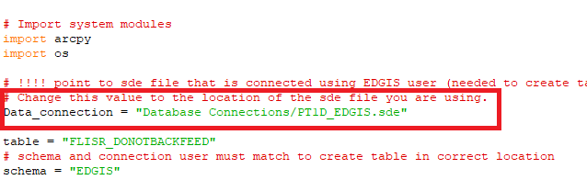
6. Making sure you have an Exclusive Lock on the database, Select the Run menu from the menu bar and select Run Module

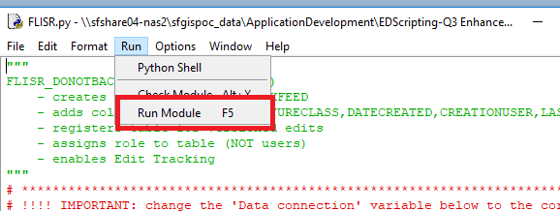

1. Wait for the script to complete, it will take about 1 minutes. The output window will list the steps as it processes and will list any errors that occur. If an error occurs (e.g. exclusive lock) you may need to comment out the lines that have already run and rerun after the error is resolved. A successful run will have output that looks like this: 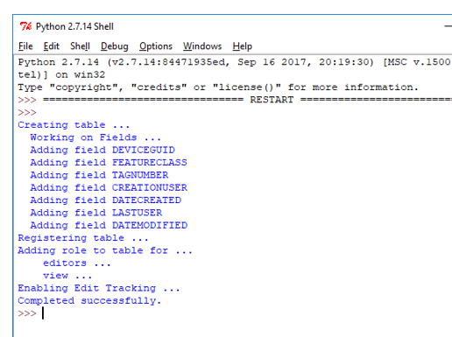

### DeviceGroup

1. In ArcCatalog: Create a sde connection to the database being modified with the EDGIS user credentials and copy the path of the sde connection from the address bar to be used in the python scripts below.



1. Verify that you have an exclusive lock on the database being upgraded and close ArcCatalog.
2. Run Python Script to update data model:
3. Navigate to \\sfshare04-nas2\sfgispoc_data\ApplicationDevelopment\EDScripting-Q3 Enhancements\Deployment\DeviceGroup
4. Right-Click on the BulkDeviceGroupName.py file and Select Edit with IDLE

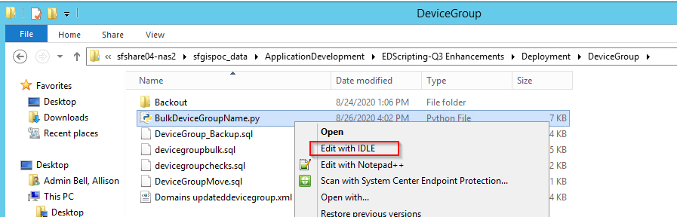

1. Modify the Data_Connection Parameter at the top of the script to match the data connection you create in step 1 and save the file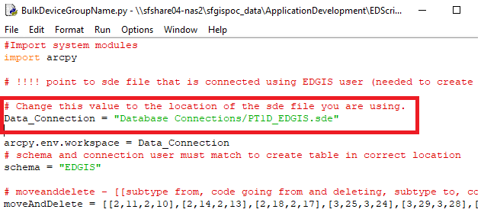
2. Making sure you have an Exclusive Lock on the database, Select the Run menu from the menu bar and select Run Module

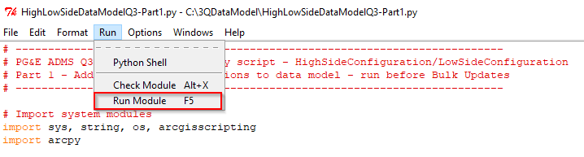

1. Wait for the script to complete, it will take about 3 minutes. The output window will list the steps as it processes and will list any errors that occur. If an error occurs (e.g. exclusive lock) you may need to comment out the lines that have already run and rerun after the error is resolved. A successful run will display ‘Finished!’ at the end.

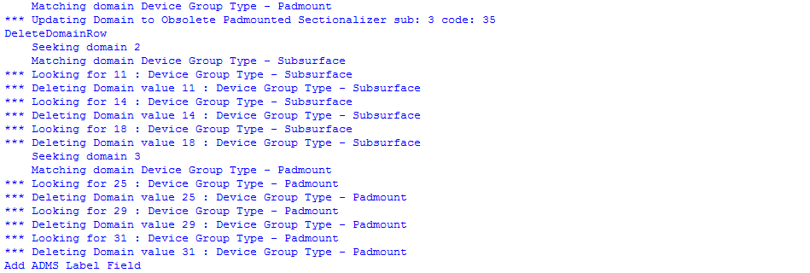



### Verify Datamodel

1. Verify the FLISR table was created in ArcCatalog: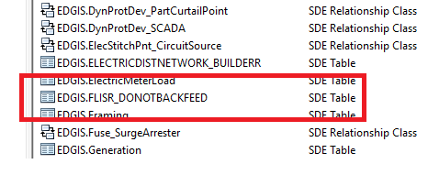
2. Verify the HighSideConfiguration attribute was created on CapacitorBank in ArcCatalog
3. Verify the HighSideConfiguration_New attribute was created on VoltageRegulator in ArcCatalog
4. Verify the LowSideConfiguration attribute was created on Transformer in ArcCatalog
5. Verify the ADMSLabel attribute was created on DeviceGroup in ArcCatalog

## Bulk Updates

### HighSideConfiguration/LowSideConfiguration

#### HighSide Logic

1. Run HighSide Bulk Update Logic
   1. Copy the HighLowSide Scripting tool from \\sfshare04-nas2\sfgispoc_data\ApplicationDevelopment\EDScripting-Q3 Enhancements\Deployment\HighSide\HighLowSideScriptingTool locally on a Server to 2 separate locations – we are going to run 2 instances of this tool concurrently to reduce the processing time. It will take a total of 20 hours to do all the feeders, so if we run 2 instances of it should take approximately 10 hours.
   2. Navigate to the first local server folder
   3. Right-Click on the PGE_CleanupTools.exe file and click Open 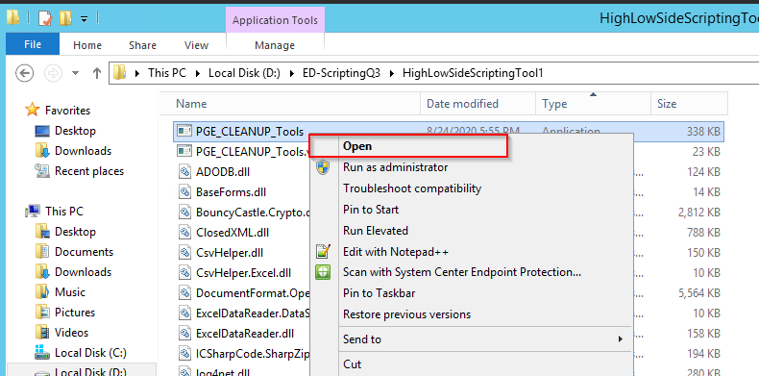
   4. Enter a sde connection path to the database using the gis_i user credentials or other user that has permissions to the geometric network. Enter the matching TNS entry, user name & password in the Cleanup Tools window and then click Connect to databases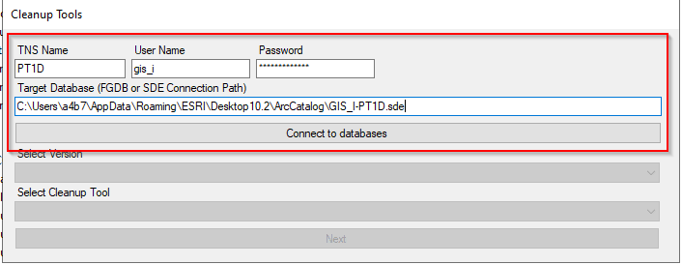
   5. After it connects, the SDE.DEFAULT version will be selected. Select the HighSide Bulk Update Logic cleanup tool and click Next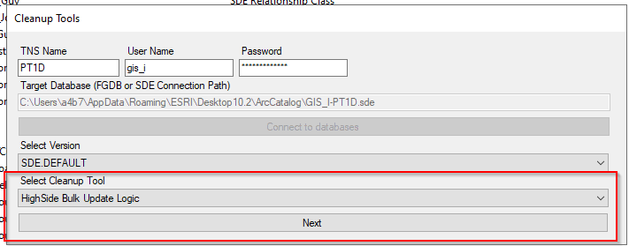
   6. Select the first half of the divisions then Click the Execute button, this could take up to 6 Hours to run: 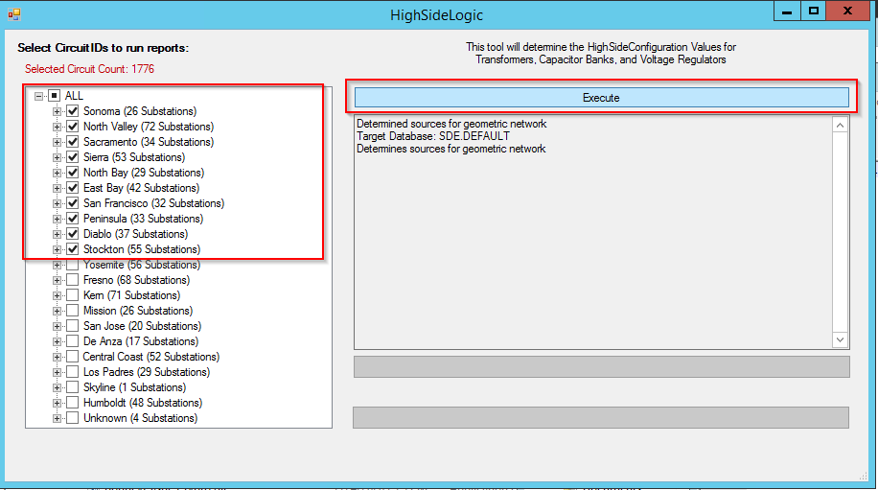
   7. Navigate to the second local server folder
   8. Right-Click on the PGE_CleanupTools.exe file and click Open 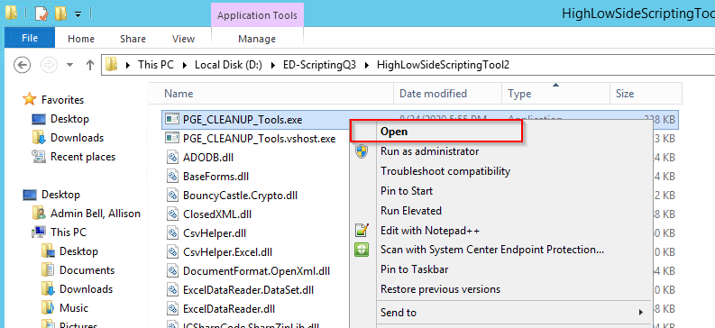
   9. Enter a sde connection path to the database using the gis_i user credentials or other user that has permissions to the geometric network. Enter the matching TNS entry, user name & password in the Cleanup Tools window and then click Connect to databases
   10. After it connects, the SDE.DEFAULT version will be selected. Select the HighSide Bulk Update Logic cleanup tool and click Next
   11. Select the second half of the divisions then Click the Execute button, this could take up to 6 Hours to run: 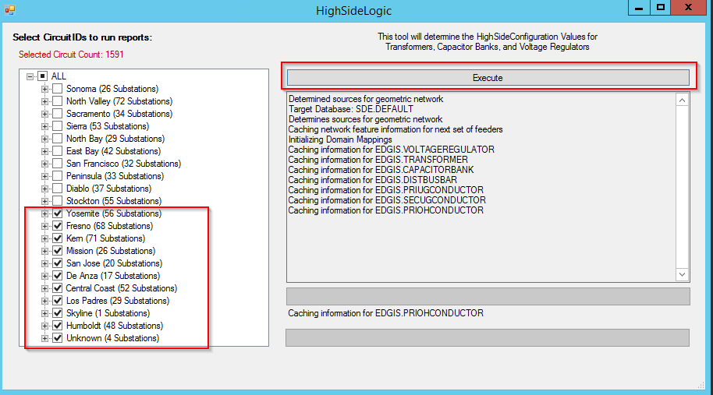
   12. Wait for both applications to finish. When it’s complete it will produce a file in each folder called 1_HighSideConfiguration.csv and the window will look similar to this: 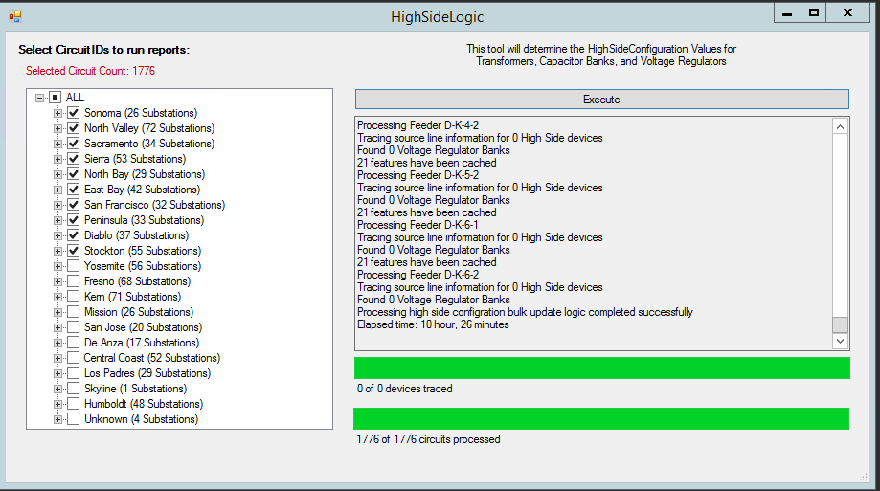

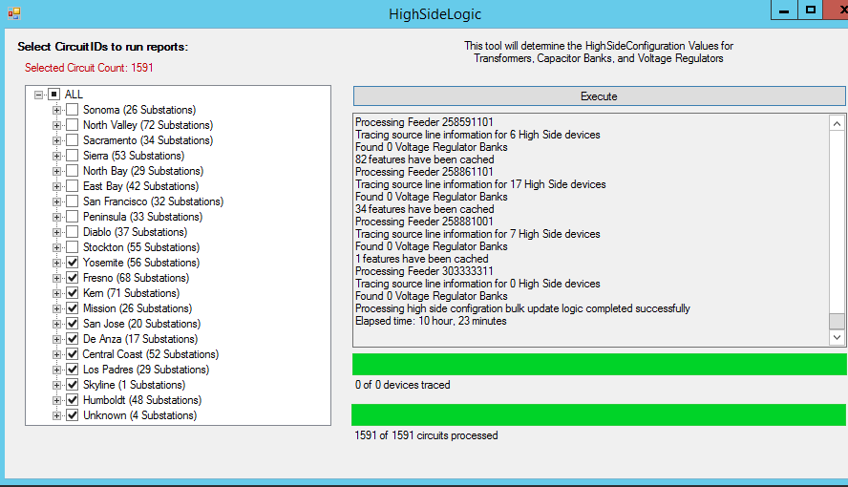

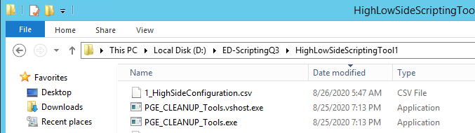

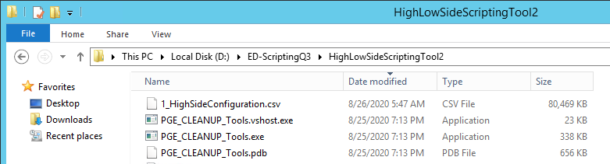

* 1. Combine the two csv output files into one file before creating the SQL Scripts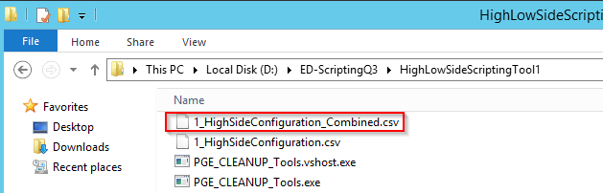

#### Create SQL Scripts

1. Create HighSideConfiguration SQL Scripts
   1. Goto the first local copy of the HighLowSide Scripting tool from the HighSide Logic step above
   2. Right-Click on the PGE_CleanupTools.exe file and click Open 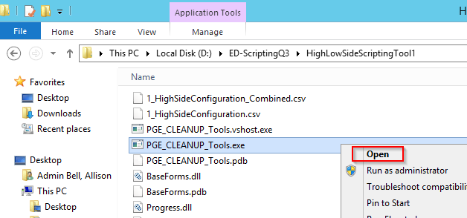
   3. Enter a sde connection path to the database using the gis_i user credentials or other user that has permissions to the geometric network. Enter the matching TNS entry, user name & password in the Cleanup Tools window and then click Connect to databases 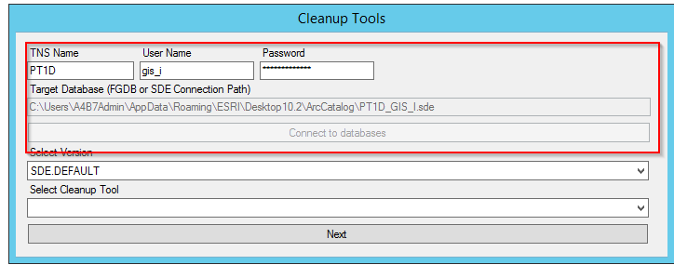
   4. After it connects, the SDE.DEFAULT version will be selected. Select the Create SQL Statements cleanup tool and click Next 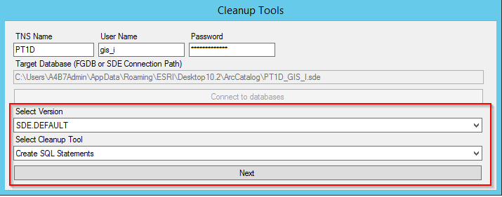
   5. Enter the path of the COMBINED csv file created in the HighSide Logic step above and select the 1-HighSideConfiguration SQL Statements and click Read CSV: 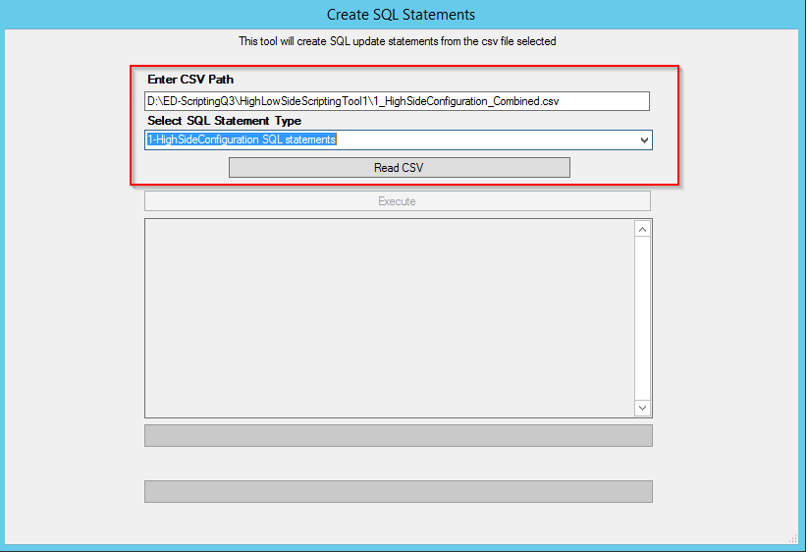
   6. Wait for the CSV file to be read. This will take approximately a minute. Then click Execute: 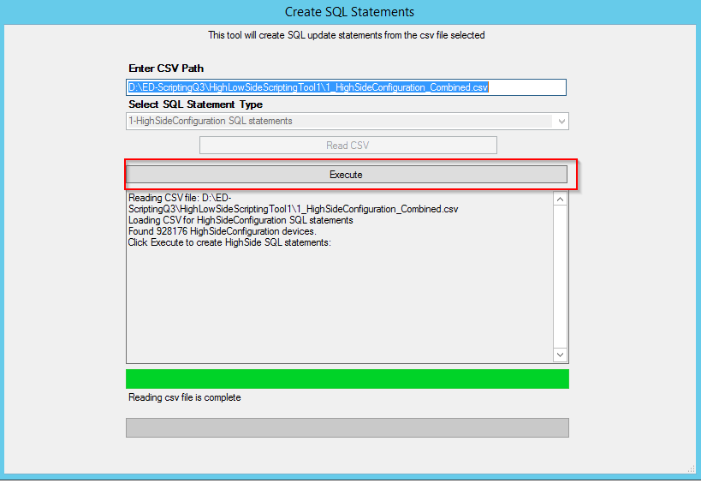
   7. Wait for the script to finish, it will take a minute or two. When it’s complete it will write out 2 SQL files. One will have the update statements, and there’s a second script that will be produced in case the bulk update needs to be rolled back during the deployment. We will only be running the update script as a part of the deployment unless something goes wrong. The window will look similar to this when its complete: 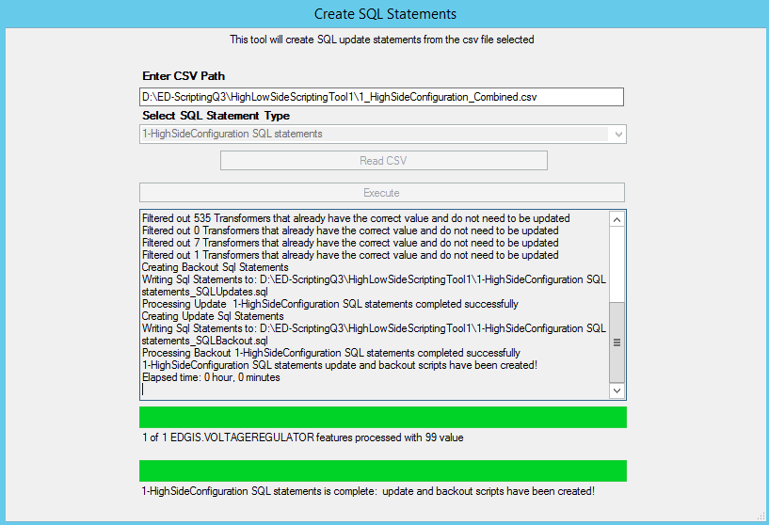

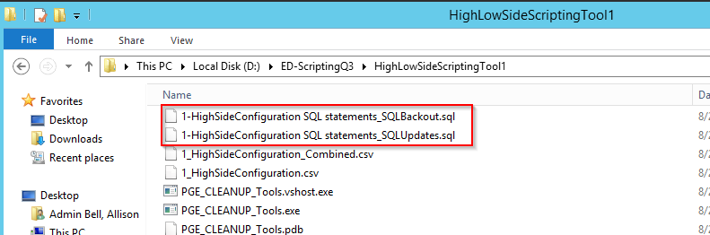

1. Create LowSideConfiguration SQL Scripts
   1. Goto the first local copy of the HighLowSide Scripting tool from the HighSide Logic Step above
   2. Right-Click on the PGE_CleanupTools.exe file and click Open 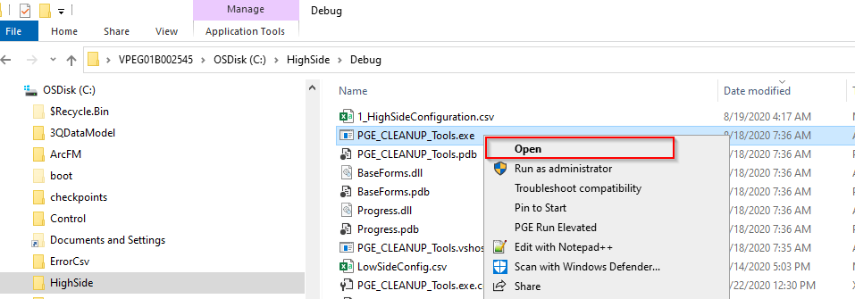
   3. Enter a sde connection path to the database using the gis_i user credentials or other user that has permissions to the geometric network. Enter the matching TNS entry, user name & password in the Cleanup Tools window and then click Connect to databases
   4. After it connects, the SDE.DEFAULT version will be selected. Select the Create SQL Statements cleanup tool and click Next

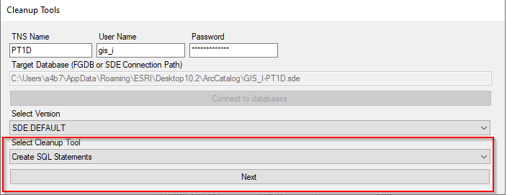

* 1. Enter the path of the LowSideConfiguration csv file provided by Derek Fletcher and select the 2-LowSideConfiguration SQL Statements and click Read CSV: 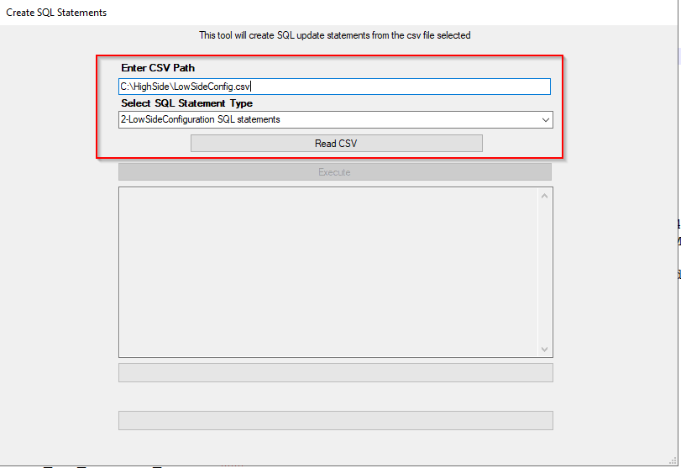
  2. Wait for the CSV file to be read. This will take approximately a minute. Then click Execute: 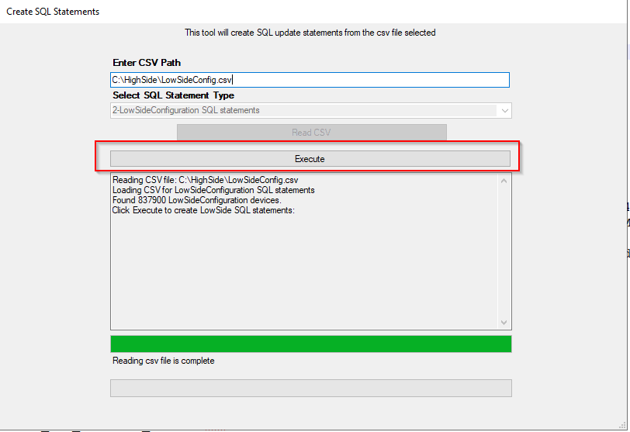
  3. Wait for the script to finish, it will take a minute or two. When it’s complete it will write out 2 SQL files. One will have the update statements, and there’s a second script that will be produced in case the bulk update needs to be rolled back during the deployment. We will only be running the update script as a part of the deployment unless something goes wrong. The window will look like this when its complete: 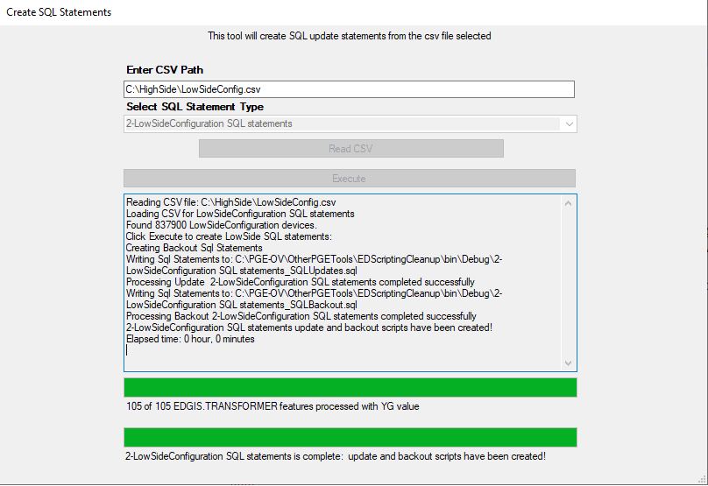 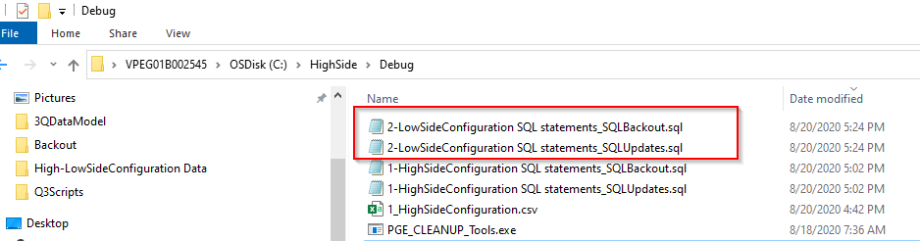

#### Run SQL Statements

1. Run SQL Bulk Updates on Base and A Tables
   1. Verify that you either have an exclusive lock or that no one else is editing the database while the SQL scripts are running
   2. Open SQL Developer and Log into the Database with an appropriate account to make bulk updates
   3. HighSideConfiguration Updates on Transformer, CapacitorBank, & VoltageRegulator
      1. Open the 1-HighSideConfiguration SQL Statements_SQLUpdates.sql file that was created in the Create HighSideConfiguration SQL Scripts step above and select the database connection to run the script with.

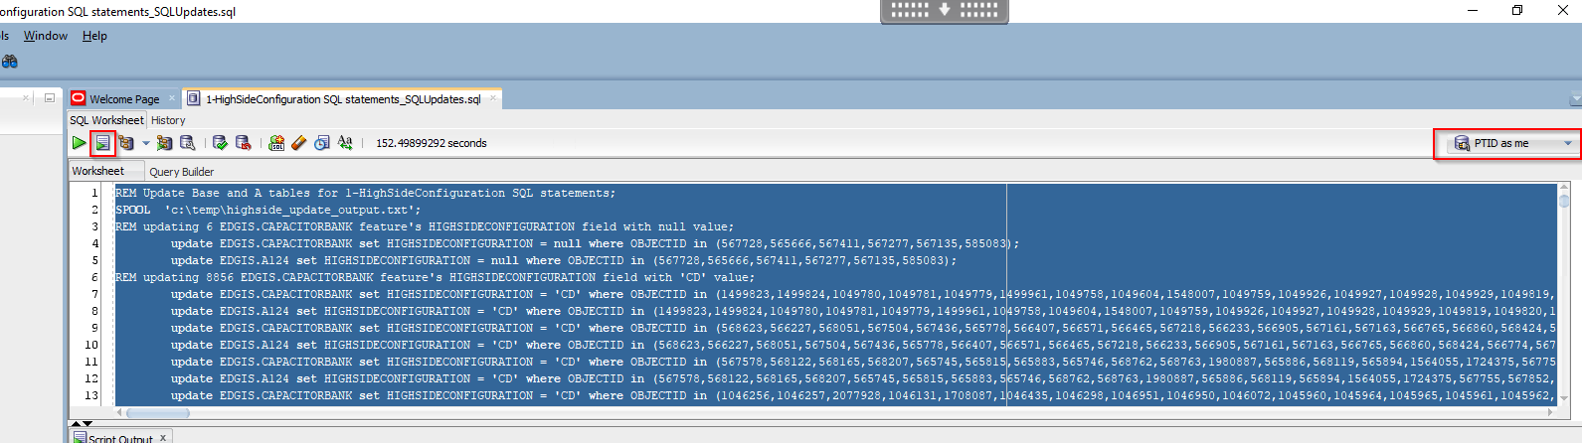

* + 1. Select Ctrl + A to select the whole file, then Click the Run Script button or hit F5 to run the script. Wait for it to complete, it will take approximately 5-10 Minutes depending on the number of versions that exist in the database.
    2. The script will spool the output to the c:\temp in a file called highside_update_output.txt. Open the file and search for errors to determine if was successful or not. Notify project team of any errors and send output to project team.
  1. LowSideConfiguration Updates on Transformer
     1. Open the 2-LowSideConfiguration SQL Statements_SQLUpdates.sql file that was created in step #7 and select the database connection to run the script with.
     2. Select Ctrl + A to select the whole file, then Click the Run Script button or hit F5 to run the script. Wait for it to complete, it will take approximately 5-10 Minutes depending on the number of versions that exist in the database.
     3. The script will spool the output to the c:\temp in a file called lowside_update_output.txt. Open the file and search for errors to determine if was successful or not. Notify project team of any errors and send output to project team.
  2. Check the counts after running the update:
     1. Open \\sfshare04-nas2\sfgispoc_data\ApplicationDevelopment\EDScripting-Q3 Enhancements\Deployment\HighSide\CheckCountsAfterBulkUpdate.sql
     2. Select Ctrl + A to select the whole file, then Click the Run Script button or hit F5 to run the script. This will be written to a file in the c:\temp directory called highside_counts_after_update.txt
     3. Send output to project team

### FLISR

1. Execute FLISR Bulk Insert
   1. Open SQL Developer and Log into the Database with an appropriate account to make bulk updates
   2. Open \\sfshare04-nas2\sfgispoc_data\ApplicationDevelopment\EDScripting-Q3 Enhancements\Deployment\FLISR\FLISRRecords.sql
   3. Select Ctrl + A to select the whole file, then Click the Run Script button or hit F5 to run the script.

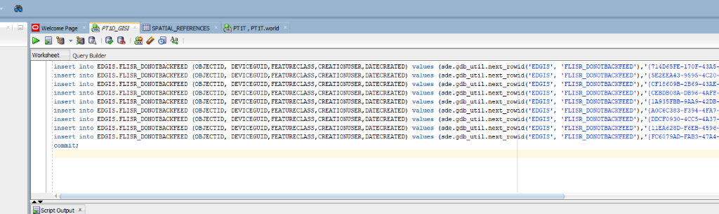

1. You should see 9 rows of *‘1 row inserted*.’
2. To confirm this statement should return a count of 9:
3. Select count(*) from EDGIS.FLISR_DONOTBACKFEED;
4. Copy results from Output window and send to project team.

### Device Group

1. Run SQL Bulk Updates on Base and A Tables
2. Verify that you either have an exclusive lock or that no one else is editing the database while the SQL scripts are running
3. Open SQL Developer and Log into the Database with an appropriate account to make bulk updates
4. Update the ADMSLabel attribute:
5. Open the \\sfshare04-nas2\sfgispoc_data\ApplicationDevelopment\EDScripting-Q3 Enhancements\Deployment\DeviceGroup\DeviceGroupBulk.sql
6. Check the 5 and 6 line to insure the two single quotes came across.

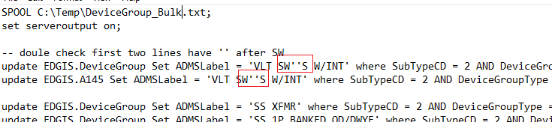

1. Select Ctrl + A to select the whole file. Click the Run Script button or hit F5 to run the script.  This will be written to a file in the c:\temp\Devicgroup_Bulk.txt directory
2. Send output to project team
3. Check the counts after running the update:
4. Open \\sfshare04-nas2\sfgispoc_data\ApplicationDevelopment\EDScripting-Q3 Enhancements\Deployment\DeviceGroup\Devicegroupchecks.sql
5. Select Ctrl + A to select the whole file, then Click the Run Script button or hit F5 to run the script. This will be written to a file in the c:\temp\Devicgroup_CountChecksAfterUpdate.txt directory
6. The output will be displayed on the screen.

## Clean Up VoltageRegulator DataModel

1. Verify that you have an exclusive lock on the database being upgraded and close ArcCatalog.
2. Run Python Script to update data model:
   1. Navigate to \\sfshare04-nas2\sfgispoc_data\ApplicationDevelopment\EDScripting-Q3 Enhancements\Deployment\HighSide
   2. Right-Click on the VoltageRegulatorHighSideDataModelQ3-Part2.py file and Select Edit with IDLE

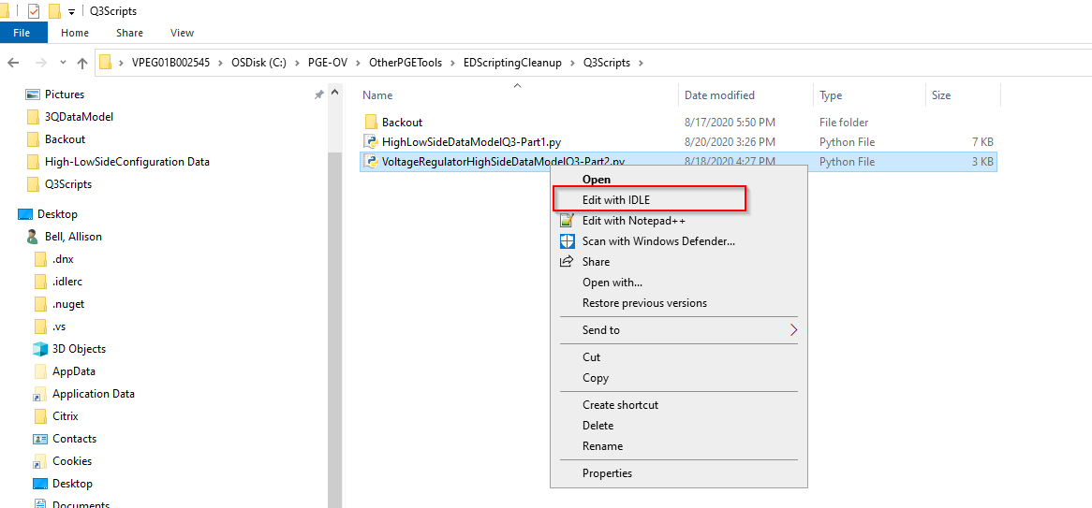

* 1. Modify the Data_Connection Parameter at the top of the script to match the data connection you create in step 1 and save the file 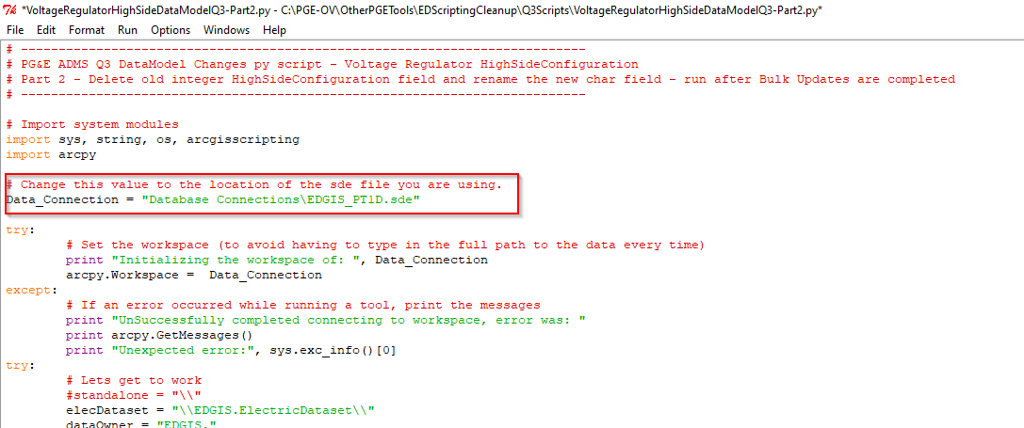
  2. Making sure you have an Exclusive Lock on the database, Select the Run menu from the menu bar and select Run Module

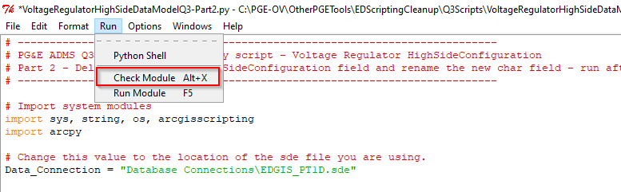

* 1. Wait for the script to complete, it will take about 5 minutes. The output window will list the steps as it processes and will list any errors that occur. If an error occurs (e.g. exclusive lock) you may need to comment out the lines that have already run and rerun after the error is resolved. A successful run will have output that looks like this:
     1. Please note that we removed deleting the old domain from the script, the domain was unable to be deleted in the test database with either SDE or EDGIS, even if we made DEFAULT public instead of protected.

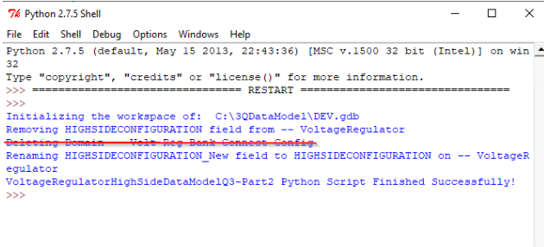

# Install EDER desktop app

1. Install EDER setup from below path on Citrix and batch servers.

\\sfshare04-nas2\sfgispoc_data\ApplicationDevelopment\EDScripting-Q3 Enhancements\Deployment\Arcgis_Desktop_1021_183

# Update ED0050 & ED0006 configuration files:

1. Replace the following configuration files on the batch server for the DMS integration: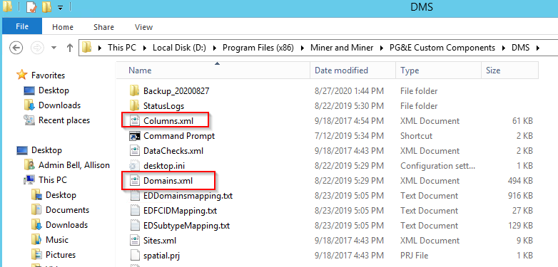

With the files from:

\\sfshare04-nas2\sfgispoc_data\ApplicationDevelopment\EDScripting-Q3 Enhancements\Deployment\InterfaceConfigFiles\ED0050

1. Replace the following configuration files on the batch server for the SAP Asset Sync integration: 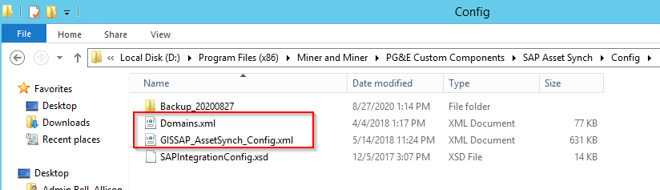

With the files from:

\\sfshare04-nas2\sfgispoc_data\ApplicationDevelopment\EDScripting-Q3 Enhancements\Deployment\InterfaceConfigFiles\ED0006

# ArcFM Properties Import

1. Make access of SDE.DEFAULT version to public by connecting to the database as SDE through Arc Catalog.
2. Close the Arc Catalog and again open it.
3. Connect to the database as EDGIS through ArcCatalog
4. Right Click on connection and Click on ArcFM XML Import as per below screenshot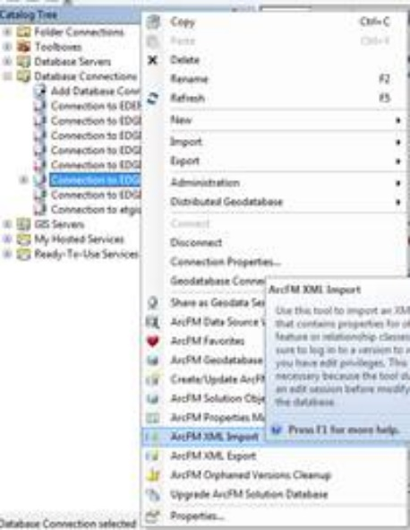
5. **Select Overwrite radio button** and click on browse
6. And select ArcFm XML Properties file one at a time, out of 13 ArcFM  from below path

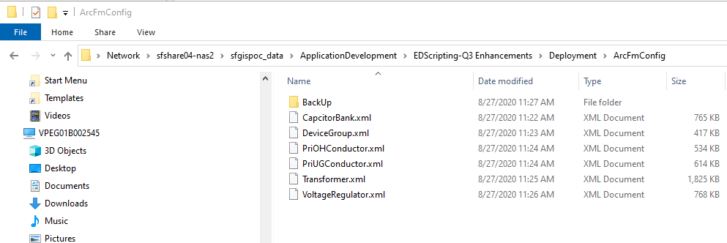

\\sfshare04-nas2\sfgispoc_data\ApplicationDevelopment\EDScripting-Q3 Enhancements\Deployment\ArcFmConfig 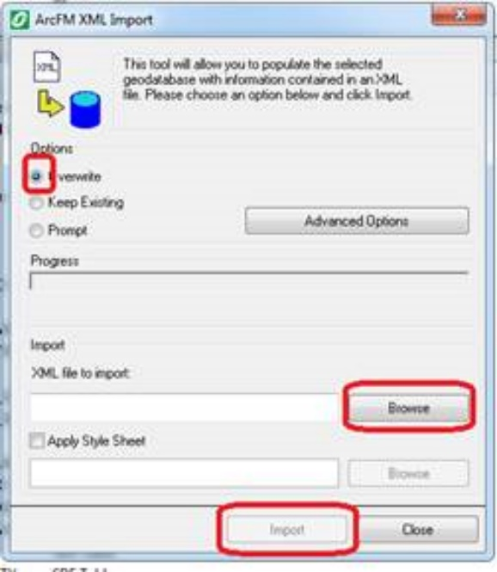

1. Click on Import (it will take ~ 1 min to complete)

(Note – In case of any Warning/Error Notification, Inform to development team)

1. Click on No as per below screen shot.

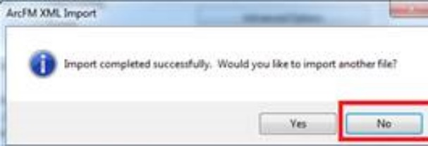

1. Repeat from 4 to 8 step for 6 different FeatureClass XML.
2. Make access of SDE.DEFAULT version to protected by connecting to the database as SDE through Arc Catalog.